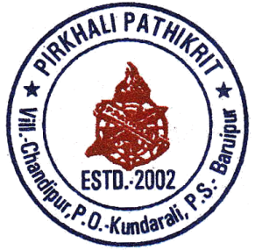

***Pirkhali Pathikrit***

* ***Ray of Hope since 2002***

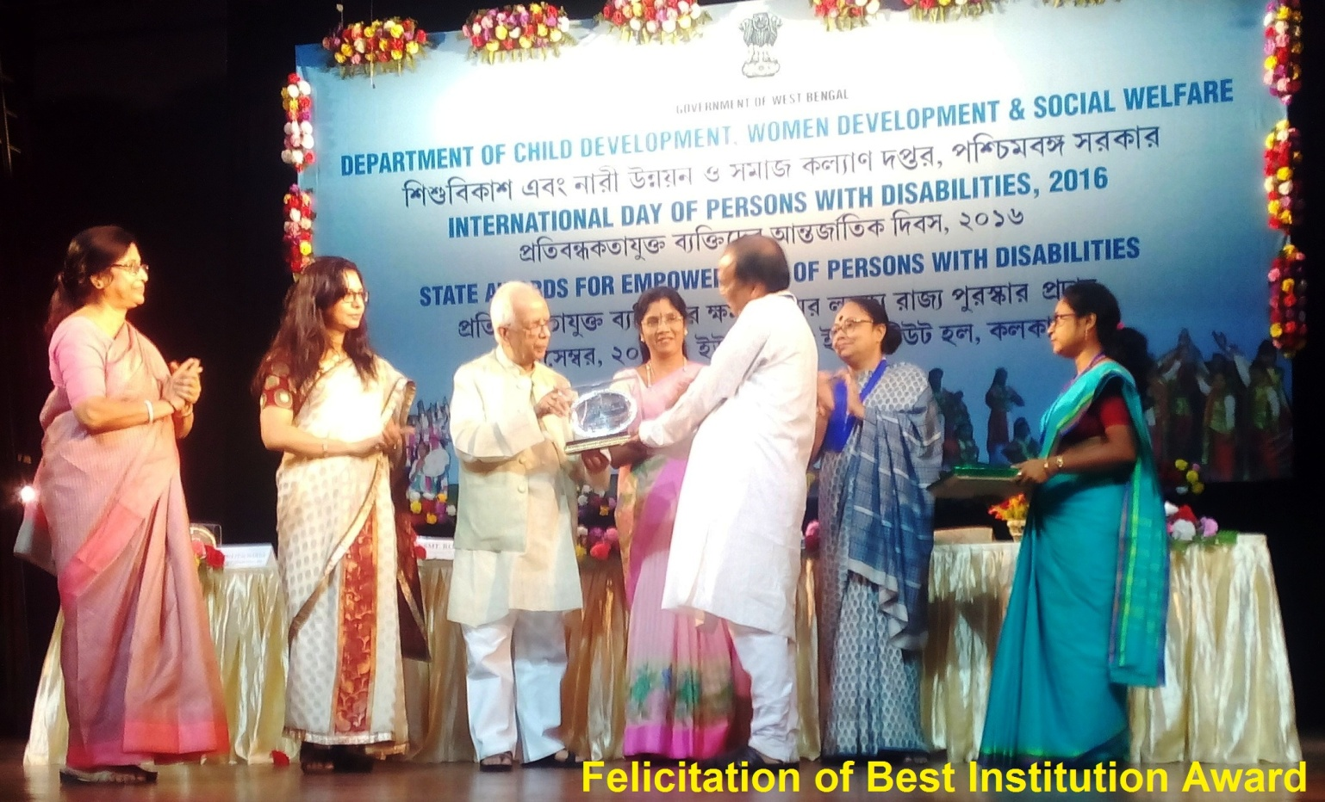

Annual Report

2018-19

**Vision**

To create a world where people with disability will be an integral part of society, participating in the community and living life to the fullest, with equitable access to opportunities and services thus creating a barrier free inclusive society.

**Mission**

* To develop an optimal mechanism for the upliftment of Rural Society, especially disadvantaged & under privileged sections, with commitment for sustainable livelihood & improved quality of life, through different developmental programs & effective application of local resources in association with community.
* To play the role of Facilitator and Catalyst to enhance the impact of rural development program through community based participatory approach.
* To facilitate enabling environments in the best interest of the child and the adult with special needs thus ensuring equitable, accessible, quality assured services using a life span approach.
* To be further informed and guided by the needs of people with disability who are further marginalized by poverty and gender inequalities.

**Message from President’s Desk**

During all these days, being the part of Pirkhali Pathikrit, I discovered that the hardest thing to overcome is not a physical disability but the mental condition which it induces. The world, I found, has a way of taking a man pretty much at his own rating. If he permits his loss to make him embarrassed and apologetic, he will draw embarrassment from others. But if he gains his own respect, the respect of those around him comes easily.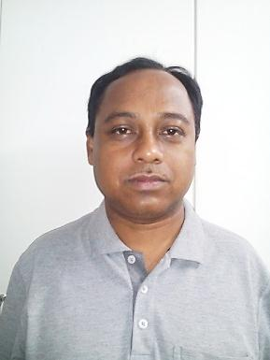 With great pleasure, I present before you the Annual Report for year 2018-2019 which narrates the best practices applied in the field of disability rehabilitation. The organization effectively provides the support in the process of improving the well-being of the Rural Population specially the marginalized and disadvantaged section of the Society with special emphasis to the children and young adults with disabilities who are often the siblings of first generation learners. The year 2018-19 has witnessed a significant development in the area of disability rehabilitation and community development, which makes us feel proud to see that the team effort of the organization has contributed significantly in improving the opportunities particularly with regards to education and livelihood for persons with disabilities. This raises our belief and expectation that nothing is more important than concentrating on societal development to address the issues of rural population and to eradicate the vicious cycle of Poverty and disability.

This year's major activities were Education and Training of children with Disability, preparation of human resources in the field of disability rehabilitation, helping poor people of the community in kind, capacity building of local Govt. Authority, organizing various skill training program.

As an organization responsive to social, cultural and educational values, PIRKHALI PATHIKRIT has been able to efficiently maintain its progression towards the betterment of its targeted population throughout these 17 years.

During this span of time, PIRKHALI PATHIKRIT has strengthened partnerships and collaboration with various agencies with regard to its program and activities to fulfill the mandate with focus on further increasing the operational efficiencies, widening the disability welfare service provisions and enhancing advocacy initiatives

None of the achievements of the year would have been possible without the efforts of PIRKHALI PATHIKRIT's dedicated team members. Members are committed to the aspirations and mission of PIRKHALI PATHIKRIT and have been relentless in delivering solutions for clients and charities. My appreciation and thanks to our Governing Body Members, staff, donors and partners. We are committed to pursuing PIRKHALI PATHIKRIT's mission with sincerity. I am very much confident that PIRKHALI PATHIKRIT will continue to provide services to poor community in the years to come and will provide valuable resources to the disadvantaged section of society. PIRKHALI PATHIKRIT has achieved considerable progress this year in beneficiary's enrollment and involvement in the developmental processes of the community. Finally on the behalf of the executive board members, I would like to thank all our donors, supporters and the villagers for their continued support.

Regards!

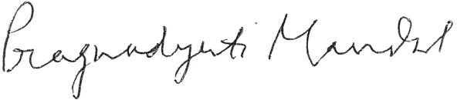

**President**

**Message from Secretary’s Desk**

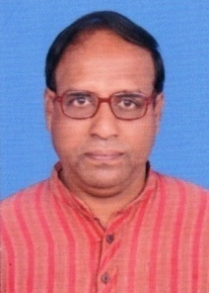We have crossed another exciting year 2018-19, which have marked successful development in all aspects of our work. We grew significantly as a team, successfully running B.Ed. Special Education (Mental Retardation) course, through our ‘Debendranath Mondal (D. N. Mondal) College’, outreach Program expanded by 60%, we took the Special Education Programme for Intellectual Disabilities Hearing Impaired in community and we developed ourselves as Individuals and as Professionals.

Being the pioneer in the District of South 24 Pgns, working for the wellbeing of persons with disabilities, PIRKHALI PATHIKRIT has been implementing dynamic and diverse program and project activities in the arena of educational intervention through ‘Disha Pratibandhi School’ focusing intellectually disabled, Cerebral Palsy, Hearing Impaired population with remarkable and recognized achievements.

Despite challenges in worldwide funding scenario, remodeling its intervention in advancing towards mainstreaming the human rights issues of diversified population of persons with disabilities, PIRKHALI PATHIKRIT remained committed to its organizational mission and vision.

This year saw us establishing ourselves as an organization committed to bringing the voices of differently abled children to the forefront as they can often be drowned out by the views of adults. We being a grass root level organization, possess fresh with spirited approach towards the rehabilitation of differently abled in the state. We firmly intend to continue and nurture this effective collaboration with all the stakeholders in our process of rehabilitation.

I am thankful to the members of the General and Executive Bodies of Pirkhali Pathikrit for their support and contribution. I really appreciate of the commitment of our staffs in implementing the programmes efficiently, providing quality services with honest, which is so crucial to ensure the purposeful journey of Prikhali Pathikrit towards realizing its vision and mission.

I would also like to thank everyone who has supported us, financially and in kind whatever form it was possible. My special and sincere thanks to Consulate General of the Federal Republic of Germany particularly the then Mr. Olaf Iversen, Counselor General of Germany, Hon’ble Ms. Shashi Panja, Minister, Government of West Bengal, Ms. Nazia Elahi Khan, etc.

We look forward to another year as we set ourselves a new benchmark for growth and build our training and education work to serve more number of differently abled children across the state.

The year was full of excitement, enthusiasm, and togetherness yet challenging and definitely with shared understanding. I look forward to more possibilities and openings in the field of disability rehabilitation and community development program keeping in alignment with our vision and mission.

Regards,

**Secretary**

**About us**

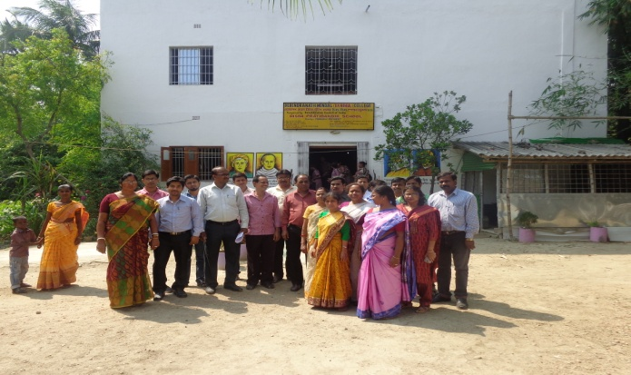Since 2005 PIRKHALI PATHIKRIT has been an integral part of the chain of care for people specially children with hearing impaired and mentally retarded in South 24 Pgns district. The projects have changed the lives children by providing services to support them in reaching their definition of recovery:

* ***Care with a human touch****:* ensuring effective treatment with a model that combines medication and ***rehabilitation****:* psychological therapies, vocational training, occupational therapy and reintegration with communities.
* ***Understanding & awareness for change****:* sensitizing communities, schools, Panchayats, government bodies and other stakeholders to encourage a change within policy and civil society that allows those differently able to live lives of their choosing in dignity and respect.
* ***Education****:* empowering every disable individual with proper education, so as they can stand on their own.

**Philosophy**

Every individual is truly special for the very fact that they exist - in spite of all of the odds. Each of these special lives deserves careful treatment and care to nurture it to fulfillment - from whatever background it was born into and whatever circumstances have impacted its development.

PIRKHALI PATHIKRIT began as a direct and heartfelt response to the visible gaps in care and attention for wandering women with mental health problems - in the eyes of society they simply did not 'exist' and there were no services to help them recover their lost lives. In the years since inception, PIRKHALI PATHIKRIT saw many more of these lost lives and designed the missing services to reach out to all providing the tools for a new life.

The philosophy is to help people find their own path to fulfillment - as everyone is unique and has individual needs, aspirations and capacities.

**Our Objectives**

* To promote accessibility to primary and higher education among the Hearing Impaired, Intellectually Disability and Underprivileged people using technology.
* To facilitate livelihood opportunities through market driven vocational training and placement support.
* To ensure continued education for children with disabilities in public schools through mid-day meal program.
* To promote sports, arts and culture among persons with disabilities.
* To promote eco – friendly living and sustainable waste management practices as an innovative vocational opportunity for the disabled.
* To establish and execute community based rehabilitation centers for special target groups like destitute youth and neglected children.
* To work at national and international levels to achieve the objectives of UN Convention on Rights of Persons with Disabilities.

**Through our work we will**

* Facilitate, nurture and support opportunities for leadership and greater involvement of people with disability in decision making regarding their own lives and the processes within their community.
* Influence and develop systems and processes to ensure that there is no exclusion, exploitation or stigmatization of the persons with disability at the levels of policy and its implementation within their community.
* Research, develop and implement service delivery models that can be adapted according to geographical and cultural realities/ contexts.
* Build technical, financial and human resource capacities of
* People with disabilities/ their families.
* Professionals
* Larger community
* Build technical, financial and human resource capacity of PIRKHALI PATHIKRIT
* We are consciously aware of the fact that creating a 100% educated and empowered society shall only be a constant process, and to achieve even the nearest practical figure would take a lifetime, Team Pirkhali Pathikrit is extremely particular about the kind of projects that it undertakes. We believe in rationales!

**Values and Guiding Principles**

Our work is guided by the core human values of respect, dignity and the autonomy of persons with disability and their careers. Strengthening capacities of all stakeholders will be central to our work. We will work towards being collaborative, participative, strategic, transparent, equitable, non-discriminative, accessible, and accountable in all that we do. We will follow the norms of safety and quality assured services in our work.

**Directions**

* Reduce the service gap: Access, Quality, All life domains, well being, safety and permanence
* Reduce the inclusion gap
* Reduce the participation gap
* Reduce stigma and exploitation
* Reduce the resource gap: Technical, Financial and Human Resource

**Strategies**

* Facilitate enabling environments
* Facilitate rights based quality assured services
* Strengthen capacities

**EXECUTIVE COMMITTEE – PIRKHALI PATHIKRIT**

|  |  |  |
| --- | --- | --- |
| Sl. No. | Name | Designation |
| 1 | **Dr. PragajyotiMondal** | **President (General)** |
| 2 | **Dr. Prabir Banerjee** | **Vice President (Working)** |
| 3 | **MadhusudanMondal** | **Secretary** |
| 4 | **JagadishSardar** | **Asst. Secretary** |
| 5 | **DebashisMondal** | **Treasurer** |
| 6 | **SaraswatiMridha** | **Member** |
| 7 | **Gopal Chandra Ghosh** | **Member** |
| 8 | **Chhanda Ray** | **Member** |
| 9 | **PurnimaMandal** | **Member** |

**OUR SERVICES AND ACTIVITIES**

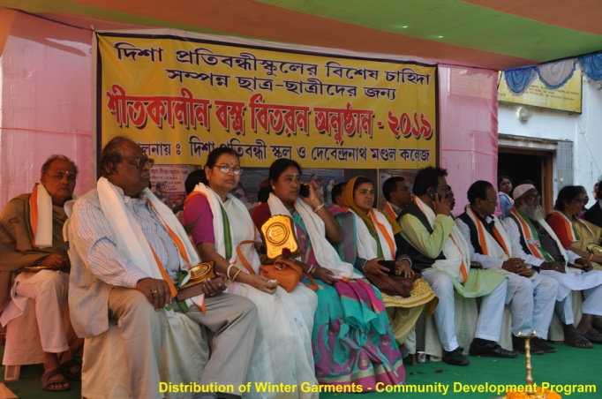**DISHA PRATIBANDHI SCHOOL – An Inclusive Set up for Children with and without Disabilities**

Children with Intellectual Disability associated with other disabilities like Autism, Cerebral Palsy, Down Syndrome and Hearing Impairment experience problems while attending mainstream schools unless they receive proper help and support. They may not become properly integrated, and they tend to be kept in the background as they try to avoid standing out from their classmates.

“Disha Pratibandhi School” has been providing special education to the children with Intellectual Disability associated with other disabilities & Children with Hearing Impairment through the technical efforts of our well trained staff having updated knowledge and skill in special education.

The extraordinary thing about DISHA PRATIBANDHI SCHOOL is the lush green atmosphere enriched with love and the extraordinary support it gets from its vibrant Parent/Teachers Relationship.

Children are given various kind of therapeutic interventions like Physiotherapy, Speech Therapy, Music Therapy, Yoga Therapy and Special Education services. The behaviors of children are streamlined by the use of modern techniques of Behavior Modification and other psychological principles. A team of interdisciplinary professionals give their dedicated and sincere efforts to the students and parents on daily basis.

DISHA PRATIBANDHI SCHOOL is an exclusive Institute trying its best through its various programme such as Disability Prevention, Early Identification, Early Intervention and Comprehensive Education with the help of multi-disciplinary professionals.

Education to the Hearing Impaired and Intellectual Disability is based on personal and interactive approach. The programme is supported from Mass Education & Extn. Dept. along with Library Science Dept., Govt. of West Bengal. The school is perceived to be one of the best in the South 24 Parganas region. Earlier the school was up to VIII std. Now it has been planned to upgraded it to secondary level.

Efforts are given in the following manner;

* Class Room Teaching
* Physio Therapy
* Speech Therapy
* Dance
* Art & Craft
* Games / Sports
* Vocational Training
* Life Skills
* Medical Checkup by doctors

**Teachers Training Programme**

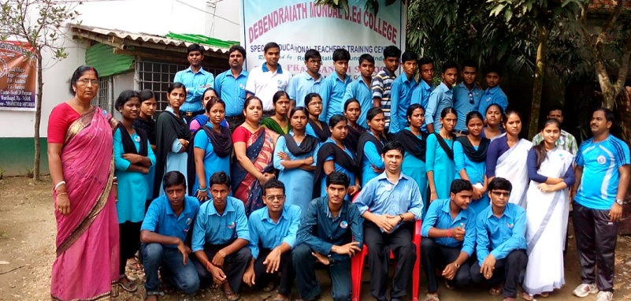One of our important challenges was to develop a qualified work force of special educators and create a work environment for them that can sustain involvement and commitment. This motivated us to start a diploma course on August 12, 2007, which saw the inauguration of the **TEACHERS TRAINING PROGRAMME**with the introduction of a year-long certificate course in Special Education (for teaching the Intellectually Disabled and Hearing Impaired).

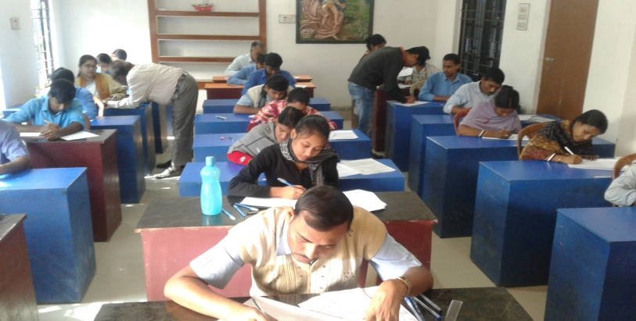Debendranath Mondal (D. N. Mondal) College is the recognized teacher training institute recognized by Rehabilitation Council of India (RCI), which is a statutory body under the Ministry of Social Justice and Empowerment, Department of Empowerment of Persons with Disabilities. The courses offered are:

* 1. Bachelor in Education Special Education (Mental Retardation) B.Ed.SE (MR)
  2. Diploma in Education Special Education (Mental Retardation) D.Ed.SE (MR)
  3. Diploma in Education Special Education (Hearing Impairment) D.Ed.SE (HI)

***On completion of the course, the trainee teacher will be eligible for the following jobs:***

* 1. Special educator in special school
  2. Special educator in inclusive set –up/regular school
  3. Special educator in a clinical / hospital set-up
  4. Special educator in Govt. Schools under the SSA/DSSSB programme
  5. As a regular teacher in schools (2 yrs Diploma Programmes in special education in MR and DHH / HI are equivalent to JBT/DIET).
  6. The trainee teacher will be fully trained to work in the home based training or open own center.

The Idea behind such kind of Education programmes is to develop professionals for special and inclusive education within a broad perspective of education, which Pirkhali Pathikrit felt during its endeavour. The programme intends to educate and train the aspirants to become agents of change as teaching-professionals by imbibing the required knowledge, skills and positive attitude. The education and training will enable them to seek out and sharpen the talents in the children with disability. It will also catalyze the realization that special education is all about child centric good quality education. The course gave special preference to those from rural backgrounds and from economically weaker sections of society.

Examination of both D.Ed. Spl. Ed. (MR & DHH) are conducted by National Institute for Empowerment of Persons with Multiple Disabilities (NIEPMD) and Ali Yavar Jung National Institute of Speech and Hearing Disabilities (Divyangjan)(AYJNISHD) Semester wise. Similarly, the B.Ed. Spl. Ed. (MR) is conducted by the University of Calcutta.

For the last 4 years we have also appointed the Evaluators for the Diploma Course. Some of our faculties have been appointed as exam paper setters as well.

We have currently 196 students with special needs enrolled in this centre. Our training is very comprehensive and exhaustive and so our students are highly sought after by other educational institute and NGOs.

**Crèche Programme**

In today's economy there has been a rising need for women to be a contributory member of the family in order to keep them afloat. Hence there have been a larger number of opportunities for the employment of women. Working women require support with regard to the care of their younger children especially infants. Day care is essential to the needs of both mothers and young children. Hence, crèche and day care services are not only required by working mothers but also women belonging to poor families who require support and relief for child care as they struggle to cope with burden of activities, within an outside the home.

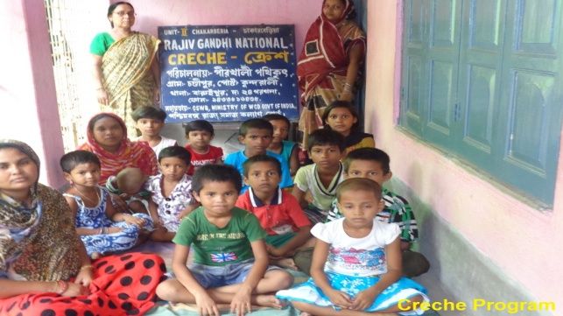

Pirkhali Pathikrit started Crèche centres in four villages of South 24 Parganas District under Rajiv Gandhi National Crèche Programme, with the financial assistance from Central Social Welfare Board, New Delhi. In each of the crèche centre 25 children are registered. Here the children are kept of those Mothers who are going outside to work.

***Objective:***

The main objective of the crèche program is to provide:

* Complete care,
* Nutritional food supplement,
* Immunization,
* Health care and Education to the children of working Mothers belonging to the Below Poverty Line (BPL) category.

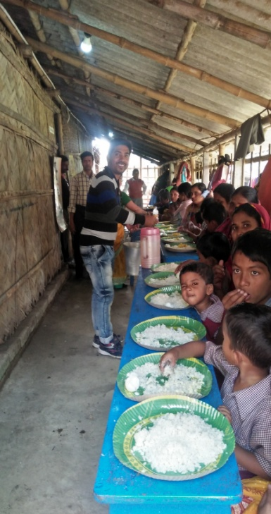***Components of the Programme:***

* + - Imparting training to crèche workers.
    - Organize pre-school education activities for the children between 3-6 year of age.
    - Organize stimulation activities for children below three year.
    - Prepare low cost teaching learning material.
    - Teach personal hygiene habits to the children.
    - Prepare nutritious food for children attending the crèche centre.
    - Keep the centre and its surroundings neat and clean.
    - Motivate parents for immunization and obtain assistance of health staff in insuring immunization of children.
    - Provide proper arrangements for sleeping and taking rest of children.
    - Insure regular home visits and mother's meetings of elicit community participation.
    - Creating awareness about better child care practices in the community.
    - Ensure weekly visits by doctors/health workers.

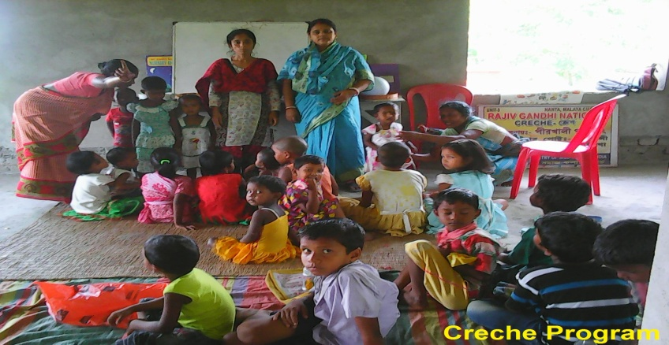***Activities :*** In Rajiv Gandhi National Crèche Centres the 25 children in age group of 0-5 years are admitted. Children are taken care of by play therapy, Joyful learning experience through music and dance, given food supplements etc. The centre runs for four hours in a day. In Nutritional food supplements they are provided Daliya, Rice, Moong Dal, Gud, Namkeen etc. every day as per the menu.

***Programmes:*** Every month the Organization provides raw material like Daliya, Rice, Gud, Moong Dal, Salt and Namkin to all the four crèche centres so that the crèche worker cook the same as per the menu and serve the nutritional food supplement on regular basis to every children coming to crèche centres.

***Outcome:*** The parents of crèche students are free from the burden of providing food and taking care of their early childhood education and they are quite satisfied that the child is in safe hand and good foster care.

**Short Term Vocational Training Programme:**

The courses are mainly focused to promote the vocational & technical training at secondary & senior secondary level. About 20% of the country population is in between the age group of 5-18 years and it is noted 70% dropouts are there from classes V to X and only 10% are going for higher education.

Keeping in view this statistics and in order to avoid the exploitation of the unskilled workers these courses are introduced. The courses are of short duration from 3 to 6 months to 1 year. After their training they join the world of work to earn their livelihood in a very short span of time.

West Bengal State Council of Technical Education (WBSCTE) has given responsibility to Pirkhali Pathikrit to conduct various Short Term Vocational Training Courses (STVT) as because a sizeable proportion of the passed - out candidates from Madhyamik and Higher Secondary level either do not get admission in higher level of studies or somehow continue the higher education without much purpose.

To divert this section of candidates towards a job - oriented programme, Pirkhali Pathikrit took the initiative to introduce Short Term Vocational Training Program of 6 months duration.

The Vocations that are trained :

* Agarbatti Making,
* Paper Products like cards, gift envelopes, bags etc.
* Candle Making,
* Sewing & Embroidery,
* Envelope Making,
* File Making

The primary purpose in the all these vocations is to impart therapy and incidentally useful products are made.

***Recognition and Approbation from –***

* **National Trust Regd. No.WPIR16511535802**
* **Niti Aayog NGO Darpan ID No.: WB / 2009 / 0022133**
* **RCI Institution Code No. WB 031**
* **PWD Regd. No. 146COM(04-05)**

|  |  |
| --- | --- |
| * **MEED ACAD. SANC. No.** | **974- MEE/Sectt.** |
| **3’s’ – 35/08** |

***Focused Geographic Area –***

Currently concentrating the social endeavour effort in South 24 Parganas region of West Bengal specially targeting the Sunderban Belt.

**Acknowledgement**

We wish to personally thank all of the funding and resource agencies that have worked with us over the years. Because of these partnerships it has become possible for us to continue and develop our work, helping to reach more disadvantaged people and take a step further towards our vision of making the society inclusive & barrier free where a children with and without disabilities can lead a healthy and dignified life.

**Audited Accounts:** 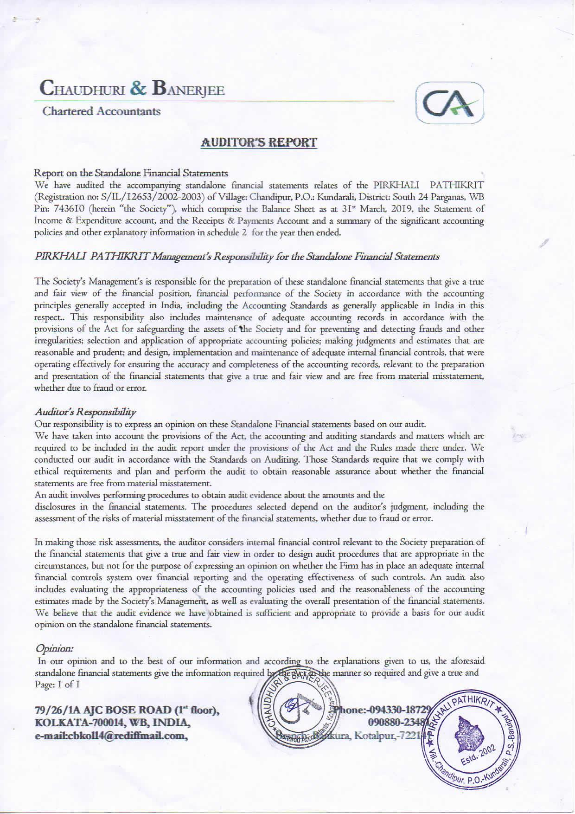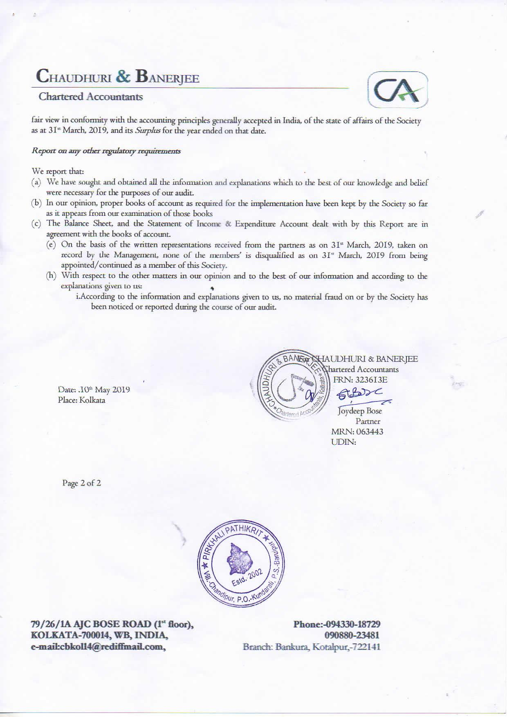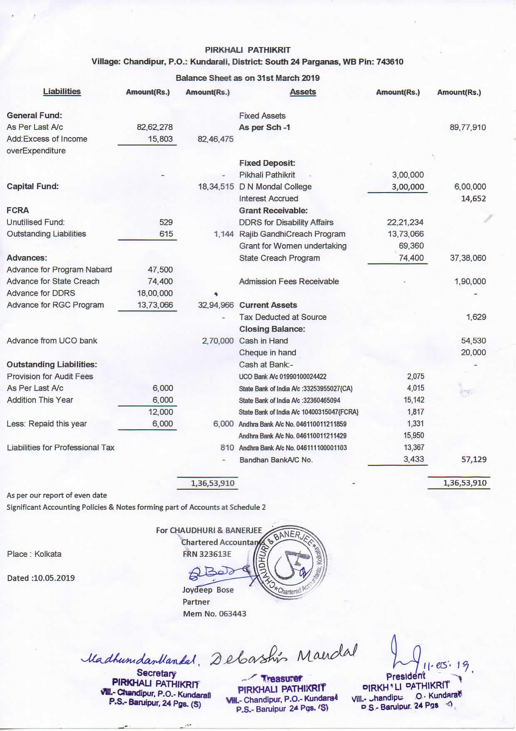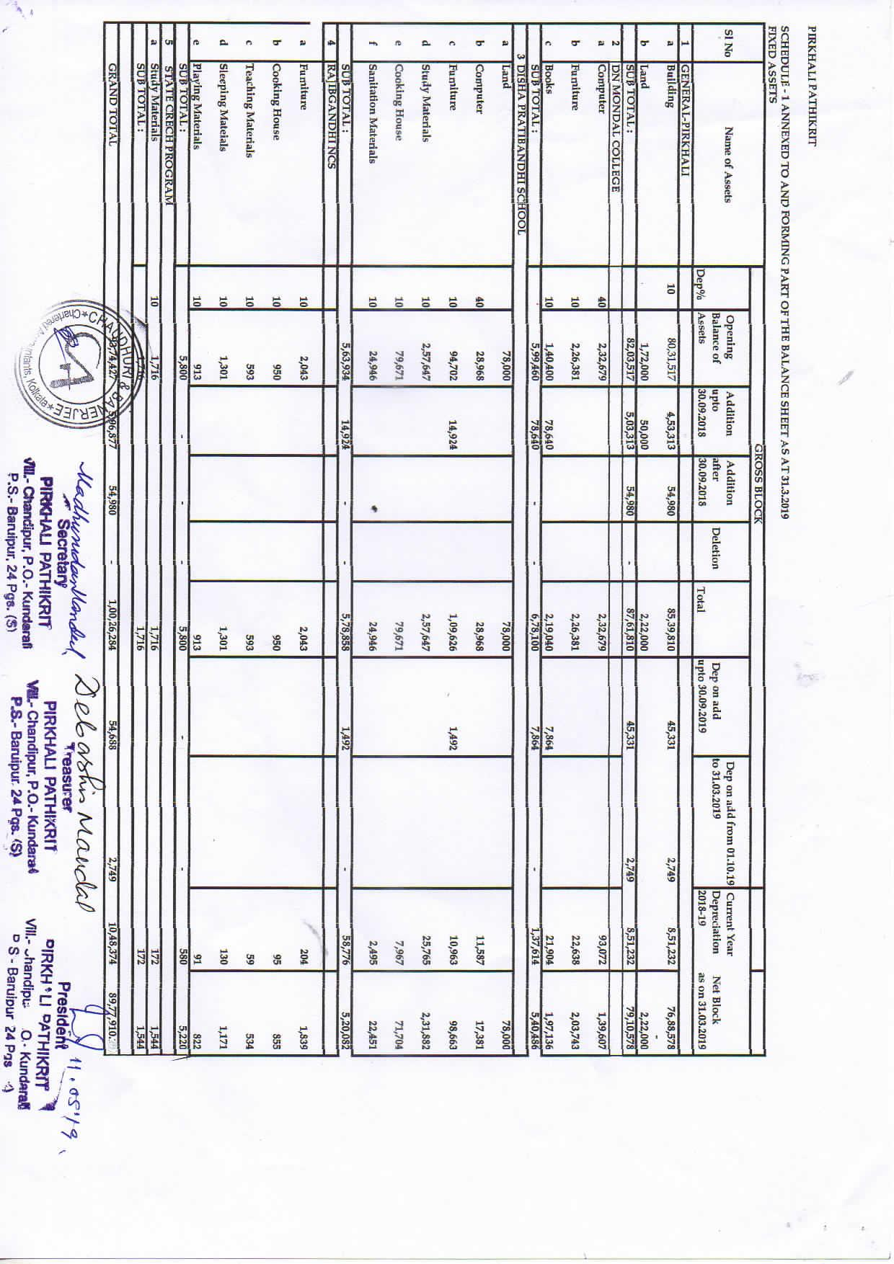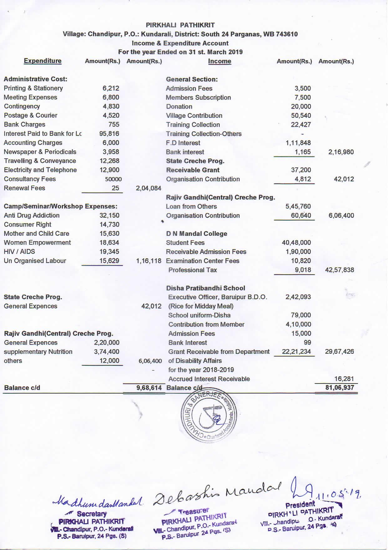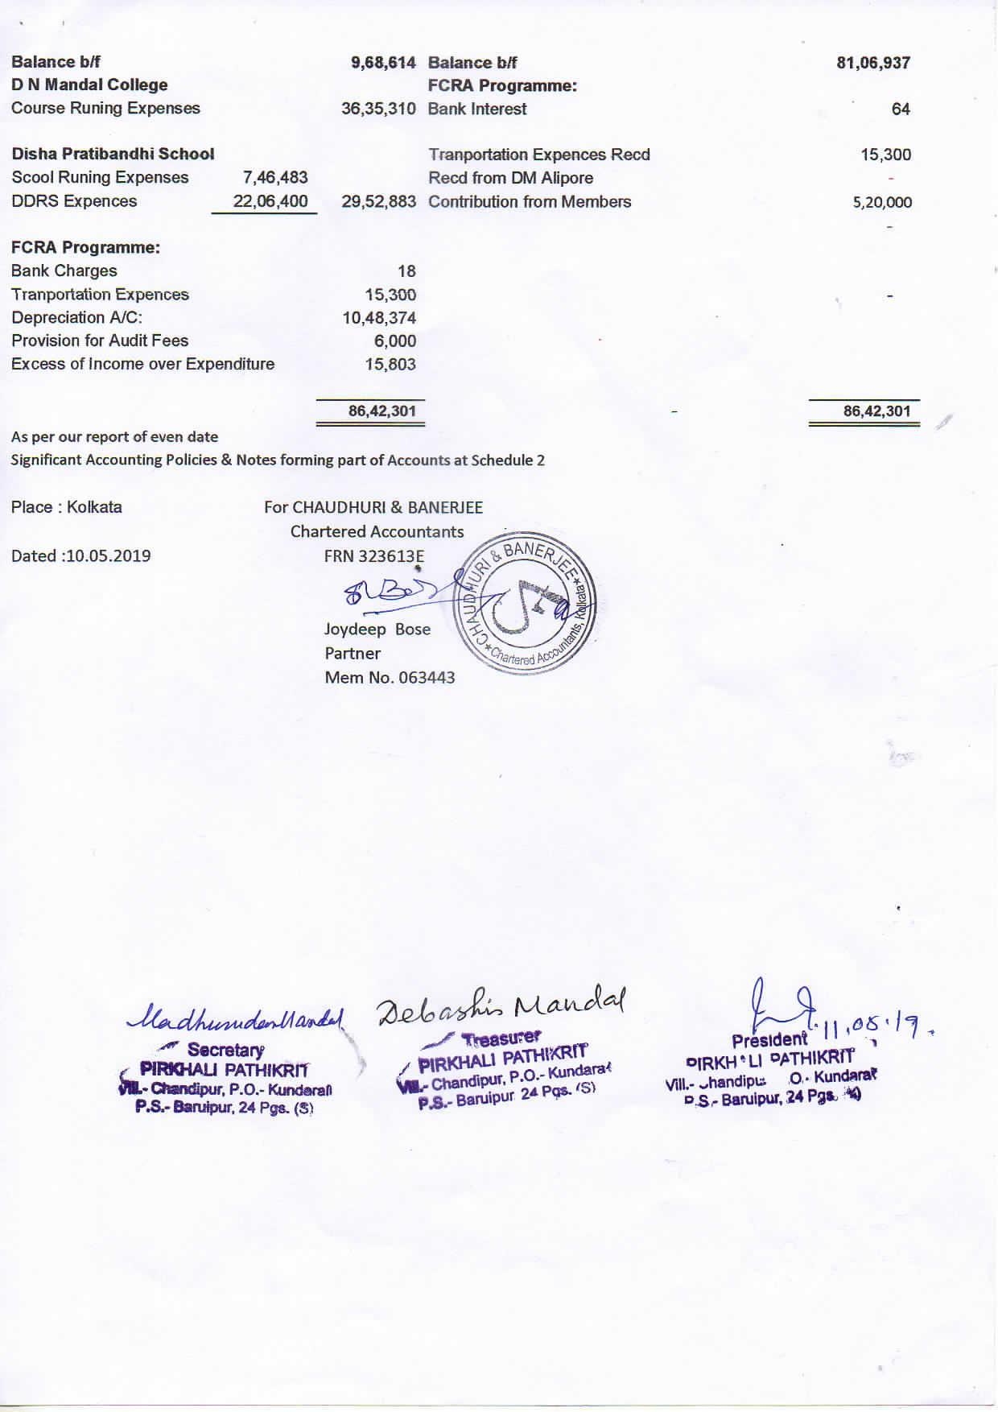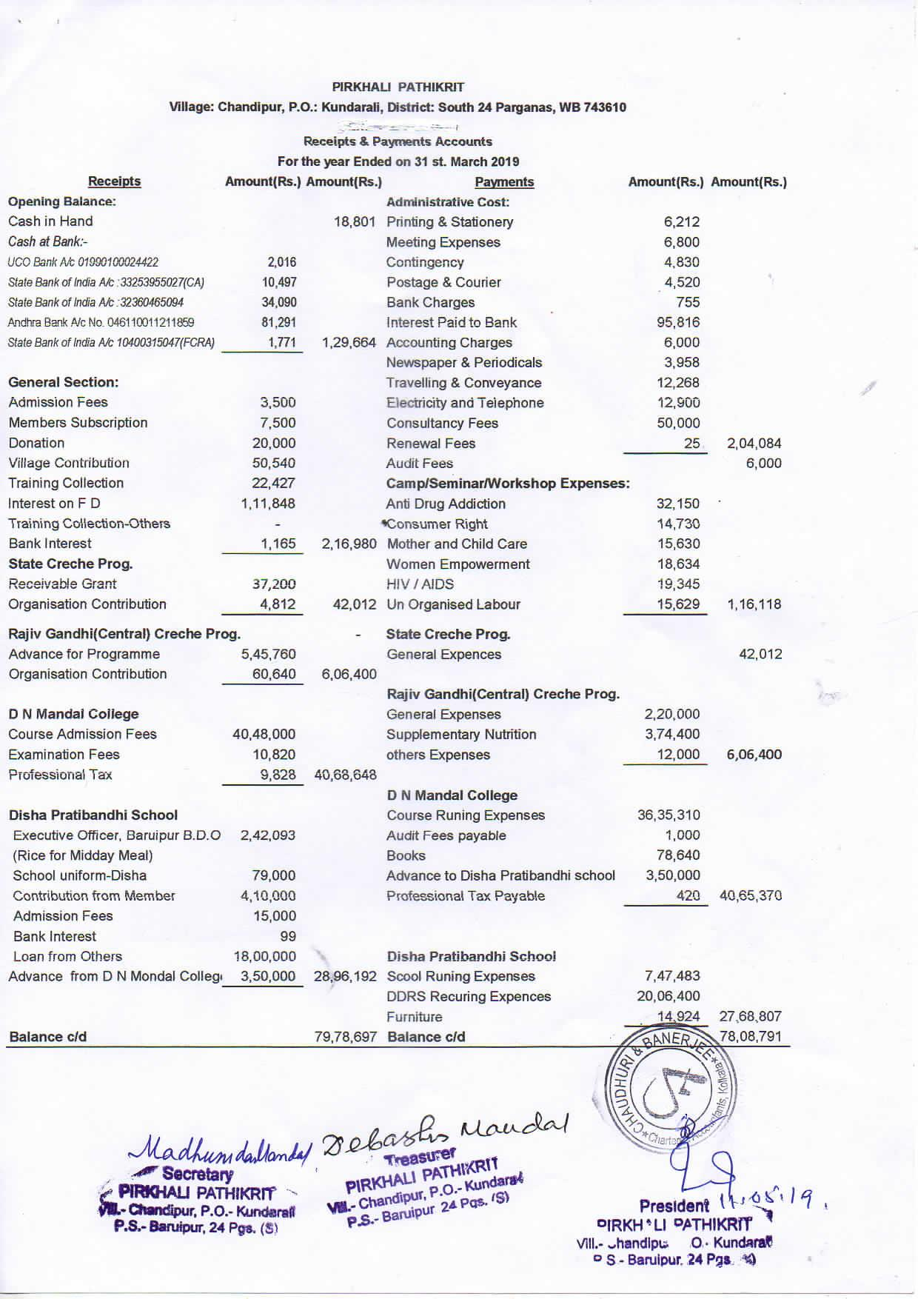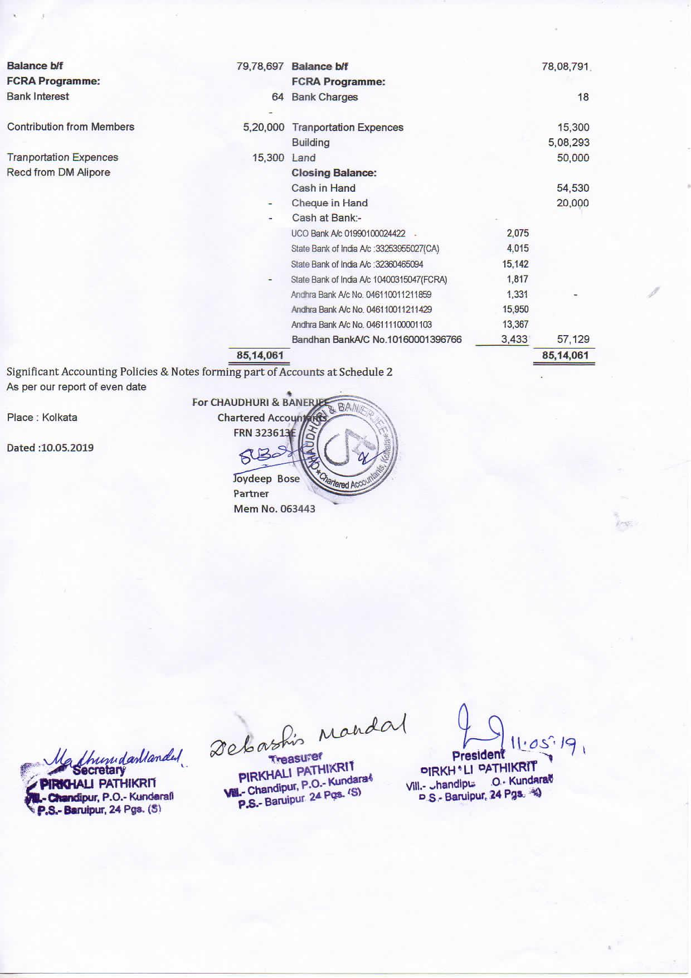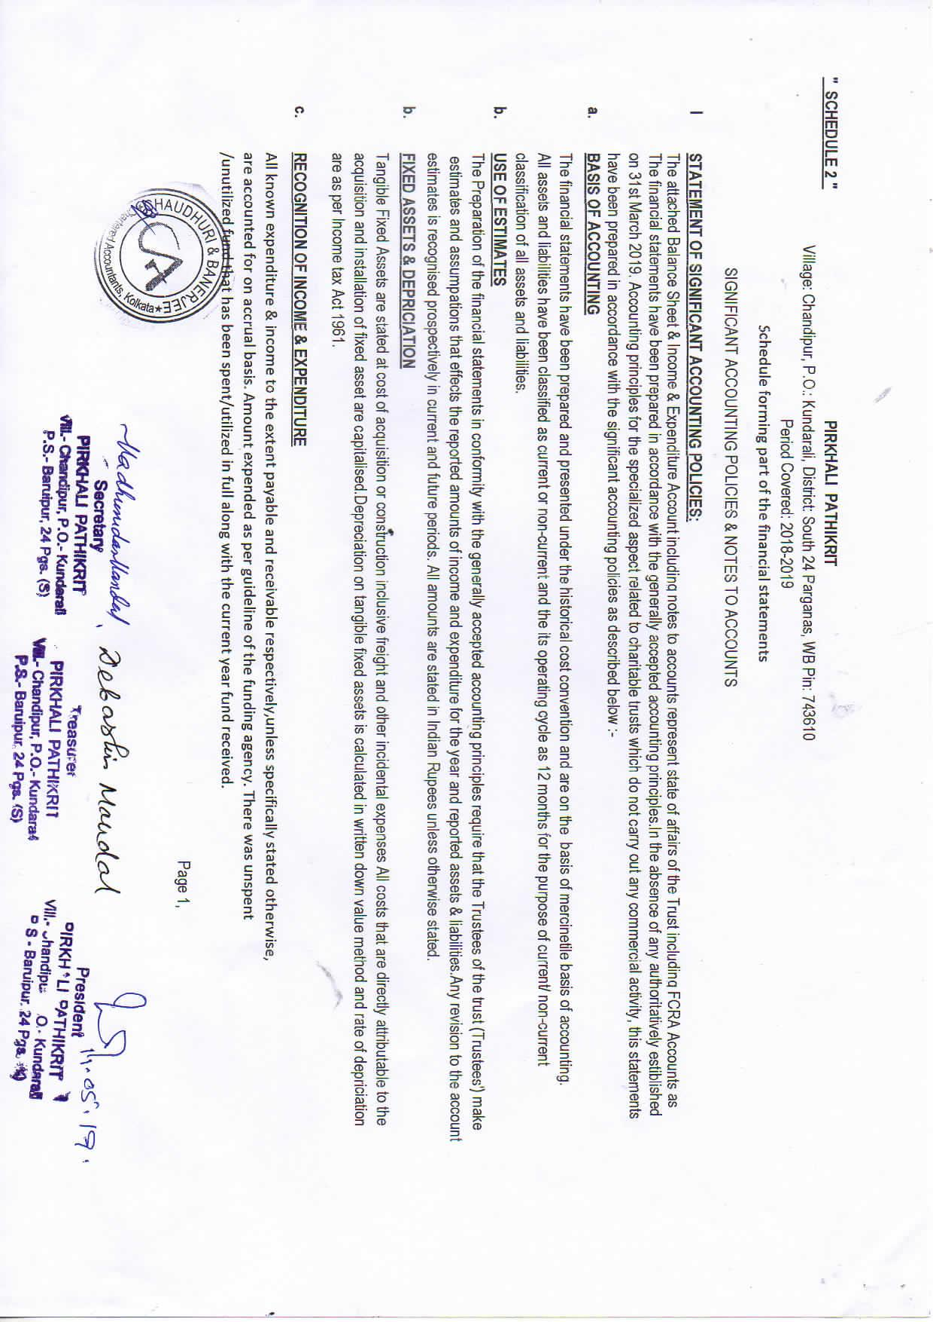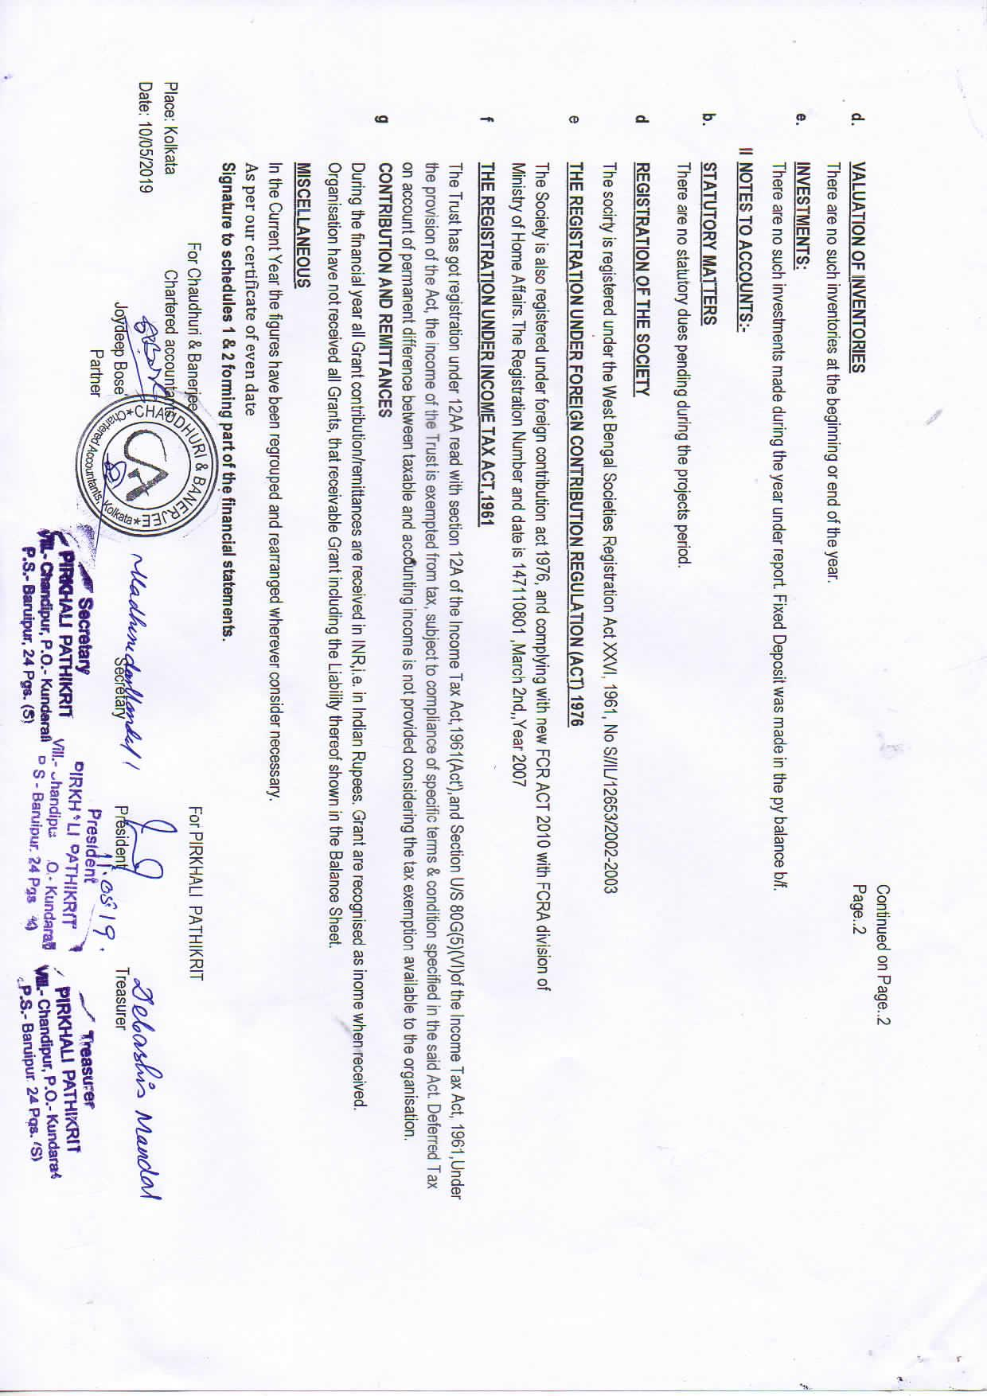

**Organogram**

**General Body**

**Administrative Division**

**College Division**

**School Division**

**Training Centre**

**Finance & Accounts Division**

**Programme Division**

**Secretary**

**Executive Committee**

**With special thanks to**

|  |
| --- |
| **Name of the Agencies / Department** |
| * Central Social welfare Board, New Delhi |
| * Ministry of Women & Child Development, New Delhi |
| * State Social Welfare Board , Kolkata |
| * Rehabilitation Council of India, New Delhi |
| * National Institute of Mentally Handicapped, Secunderabad |
| * Ali Yavar Jung National Institute for the Hearing Handicapped, Mumbai |
| * National Institute for Empowerment of Persons with Multiple Disabilities, Chennai |
| * National Trust, New Delhi |
| * Ministry of Social Justice and Empowerment, New Delhi |
| * Department of Women and Child Development and Social Welfare, West Bengal |
| * National Institute for the Orthopedically Handicapped, Bonhooghly |
| * District Magistrate, South 24 Parganas District |
| * Commissioner of the Disability, Govt. of West Bengal |
| * District Social Welfare Officer, South 24 Parganas District |
| * South 24 ParganasZillaParishad, Alipore |
| * Block Development Officer, Baruipur Block |
| * Kalyanpur Gram Panchayat, Baruipur |

***Join Hands:***

* Each year PIRKHALI PATHIKRIT touches the lives of around 3,000 persons with disability through its various roots; roots which only work with much watering from PIRKHALI PATHIKRIT's friends, donors and volunteers. Becoming part of PIRKHALI PATHIKRIT family, in whatever capacity, makes you a part of the journey and involves you in the rehabilitation and recovery of those that pass PIRKHALI PATHIKRIT's doors.
* Many of PIRKHALI PATHIKRIT's full time staff started working as volunteers, many donors have become advisers and many others have offered their enthusiasm, expertise and encouragement over the years to make the organization as wide reaching as it is today.
* We appreciate the kind of contributions in cash or kind has helped enriched the functioning of the organization. Without which it would have been impossible to sustain the mammoth activity of the organization.
* All our children with special needs belong to below poverty line, underprivileged section of society, parents are daily wages worker. Children often miss out the school due to the dire necessity of the parents to earn their livelihood. Children are malnourished due to the negligence of the parental care. Your help towards Sponsoring a child @ Rs. 15,000/- per annum will help a child grow & develop qualitatively.
* In the days to come the support from the community resources are very much essential for the accomplishment of the Vision and Mission of the organization.
* Join us in our mission to generate wellbeing and upliftment of the most marginalized sections of society and support PIRKHALI PATHIKRIT in whatever way you can.

**Credentials :**

* **Legal Status:**
* Registered under West Bengal Societies Registration Act XXVI of 1961 vide Registration No. **S/1L/12653 dated 20th November, 2002**
* Registered under Foreign Contribution Regulation Act of 1976 vide FCRA No. **147110801 dated 2nd March, 2007**
* Registered under 12A of Income Tax vide No. **DIT(E)/S-209/8E/241/2004-05/ dated 9th March, 2005**
* Registered under 80G (Perpetual) of Income Tax vide No. **DIT(E)/8E/241/04-05/543/1815 dated 13th August, 2012**
* PAN No. **AAAAP5459R**

**Bank Details:**

***(Local Donation)***

Name of the Bank: **State Bank of India**

Bank Branch Name: **Baruipur Branch**

Address of Bank Branch: **ZillaParishad Building, Kulpi Road, Baruipur,**

**District: South 24 Parganas, West Bengal, Pin: 743302.**

Branch Code: **01490**

Account in the name of: **PIRKHALI PATHIKRIT**

Account Number: **32360465094**

IFS Code: **SBIN0001490**

***(Foreign Donation)***

Name of the Bank: **State Bank of India**

Bank Branch Name: **Baruipur Branch**

Address of Bank Branch: **ZillaParishad Building, Kulpi Road, Baruipur,**

**District: South 24 Parganas, West Bengal, Pin: 743302.**

Branch Code: **01490**

Account in the name of: **PIRKHALI PATHIKRIT**

Account Number: **10400315047**

IFS Code: **SBIN0001490**

***Get in Touch with us –***

**PIRKHALI PATHIKRIT**

**Village: Chandipur, Post: Kundarali, P.S.: Baruipur**

**District: South 24 Parganas, West Bengal, Pin: 743610, INDIA**

**Phone:** 033 2423 1002

**Mobile: +**91 33 9433516435 / 8697248114

**Email:** pirkhalipathikrit@gmail.com

**Website:** www.pirkhalipathikrit.org

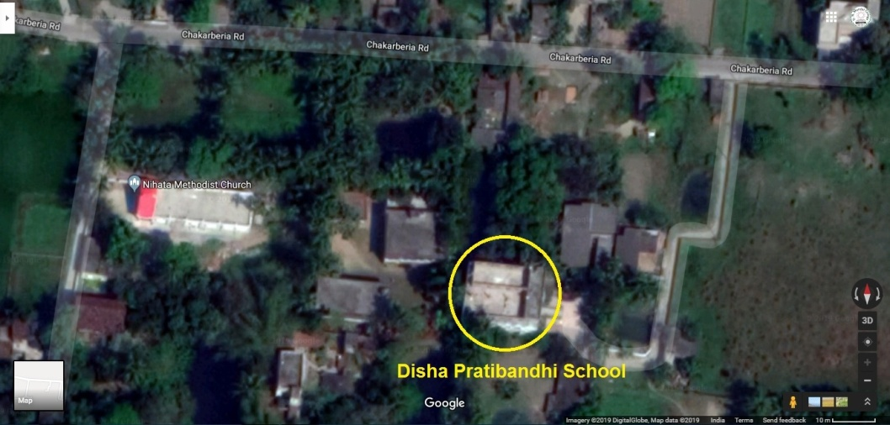

***Photographic Memory –***

|  |  |
| --- | --- |
| **MR & HI children playing in the adjacent ground of Pirkhali Pathikrit (1).JPG** | **Celebrating World Disability Day with Ms. Shashi Panja, Minister (1) --- 2015-12-03.jpg** |
| **Differently Abled children enjoying playing sports at DishaPratibandhi School ground run by PirkhaliPathikrit** | **Secretary of PirkhaliPathikrit, Mr. MadhusudanMandal seen Celebrating World Disable Day with Ms. ShashiPanja, Minister, Govt. of West Bengal** |
|  |  |
| **Ms. Nazia Elahi Khan, a renowned social worker with Mr. Madhusudan Mandal, Secretary of Pirkhali Pathikrit, seen distributing quilts to poor marginalized families having disable children.JPG** | **Visiting 5 Syndicate Members from Calcutta University during the discussion with Officials of Debendranath Mondal (D. N. Mondal) College in the Guest Room.JPG** |
| **Ms. Nazia Elahi Khan, a renowned social worker with Mr. Madhusudan Mandal, Secretary of Pirkhali Pathikrit, seen distributing quilts to poor marginalized families having disable children** | **Visiting 5 Syndicate Members from Calcutta University during the discussion with Officials of DebendranathMondal (D. N. Mondal) College in the Guest Room for the possibilities of affiliating B.Ed. Spl. Ed. (MR) Course** |
|  |  |
| **b064209e-61ef-49a8-b04f-05c2bda27ccb.jpg** | **Mr. Olaf Iversen interacting with the Secretary of Pirkhali Pathikrit during his visit.JPG** |
| **Visit of Consulate General of Japan Embassy** | **Mr. Olaf Iversen Counselor General of Germany Consulate Office in Kolkata during his benevolent visit** |
|  |  |